Lehman VPN User Documentation for Mac OS.
A VPN (virtual private network) allows users to securely connect to a private network from a public network. In this case Lehman faculty and staff are able to connect to the Lehman Network from anywhere. This allows them access resources that are regularly not available from off campus.

How to connect
To connect to the Lehman VPN you must download the VPN client. The VPN client can be downloaded from https://remote.lehman.edu/
The download and installation of the VPN client only needs to be done once. If you already have the VPN client installed you may skip to step 9.
- On any web browser navigate to https://remote.lehman.edu/ and log in with your Lehman username and password.
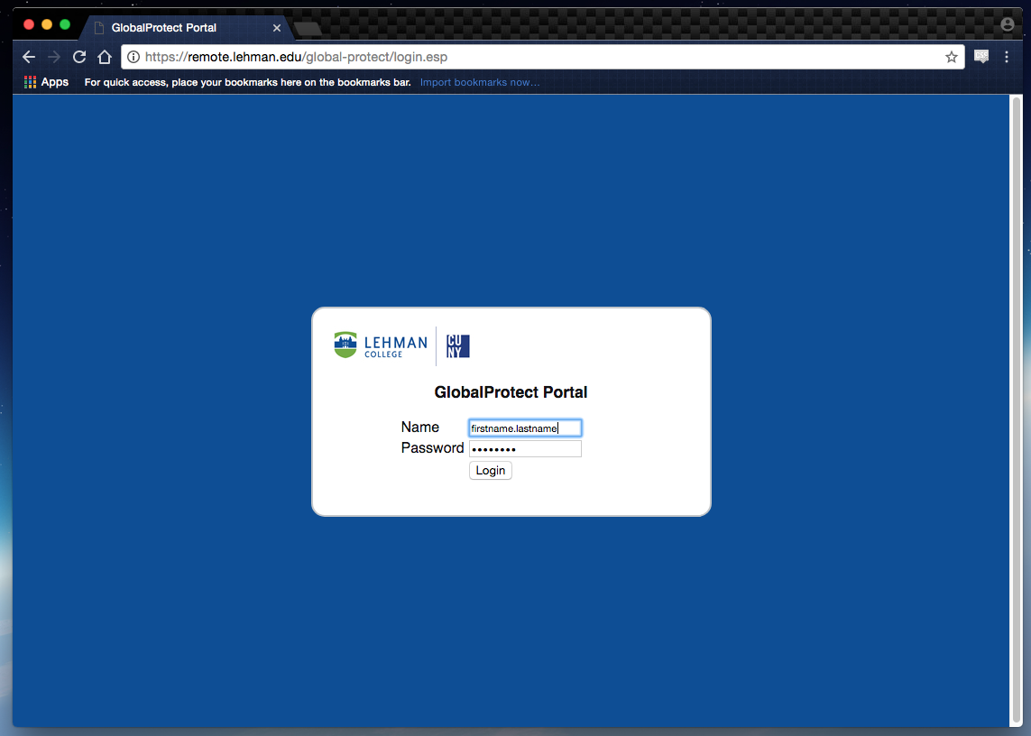

- Once authenticated you will be presented with 3 download links. Click on “Download Mac 32/64 bit Global Protect agent”

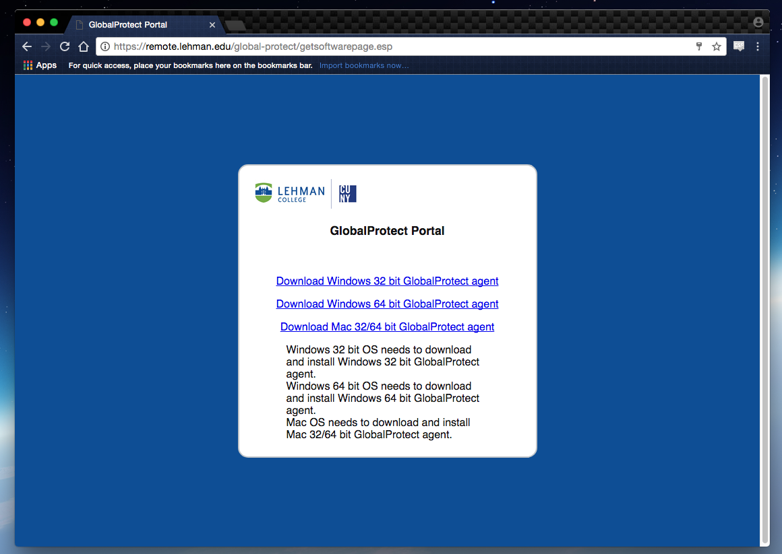
- Follow the steps in the installation wizard.

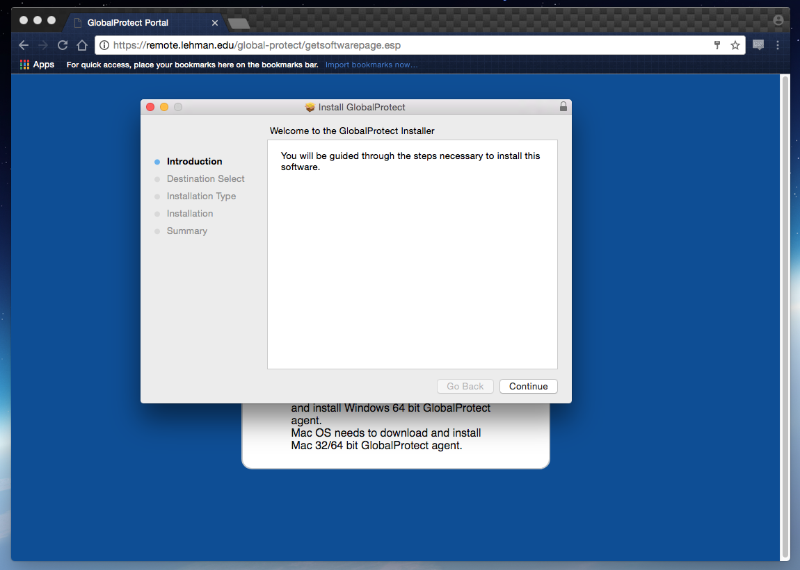

- On the installation type screen, click on the Global Protect check mark. Make sure that the uninstall check mark is not checked.

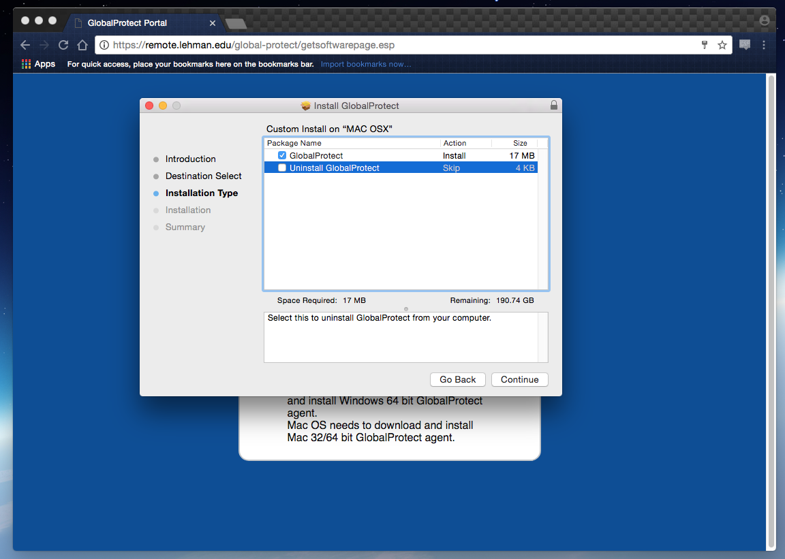
- Type in your user credentials for the computer. Administrative privileges are required to install the software in your computer
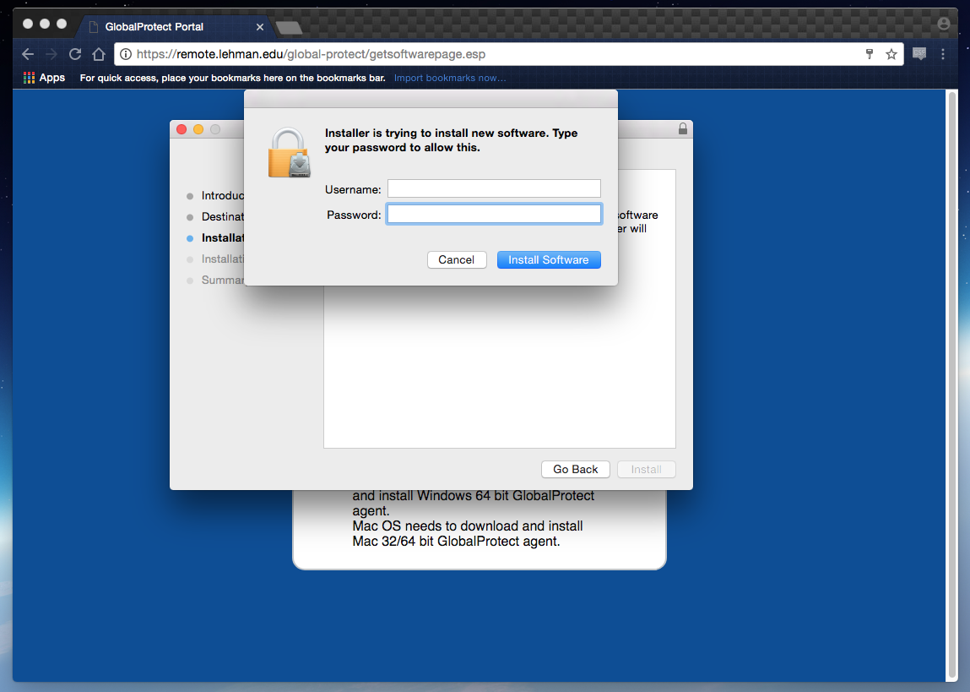

- Once the installation is complete, click on “Close” to exit out of the installation wizard.
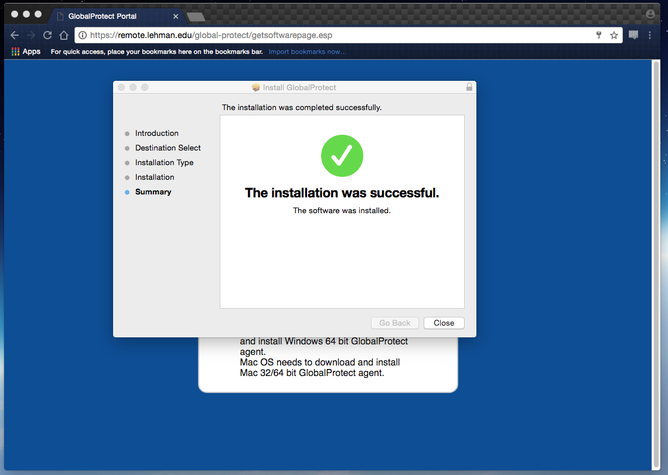
- Once installed, the application will launch automatically. Fill in the information accordingly and click on connect.
Portal: remote.lehman.edu
Username: Lehman username i.e. firstname.lastname
Password: Lehman password

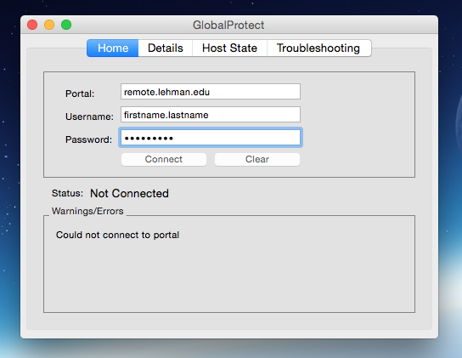
- If the connection is successful the status will say “Connected” as displayed below. At this point you should be able to access Lehman resources just as if you were on campus.
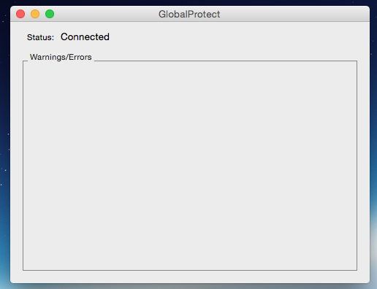
Launch VPN client from the desktop

- Go to the status menu top right corner of your desktop and click on the Global Protect icon.
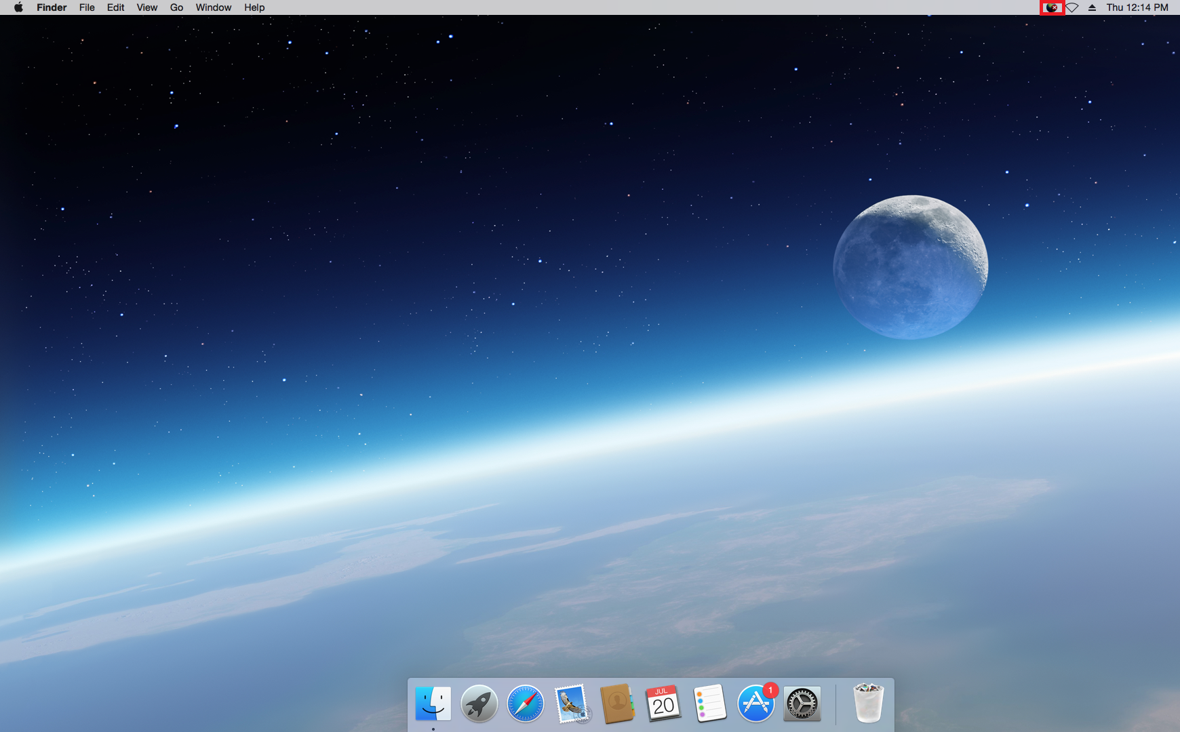

- Click on “Connect” from the drop down menu.

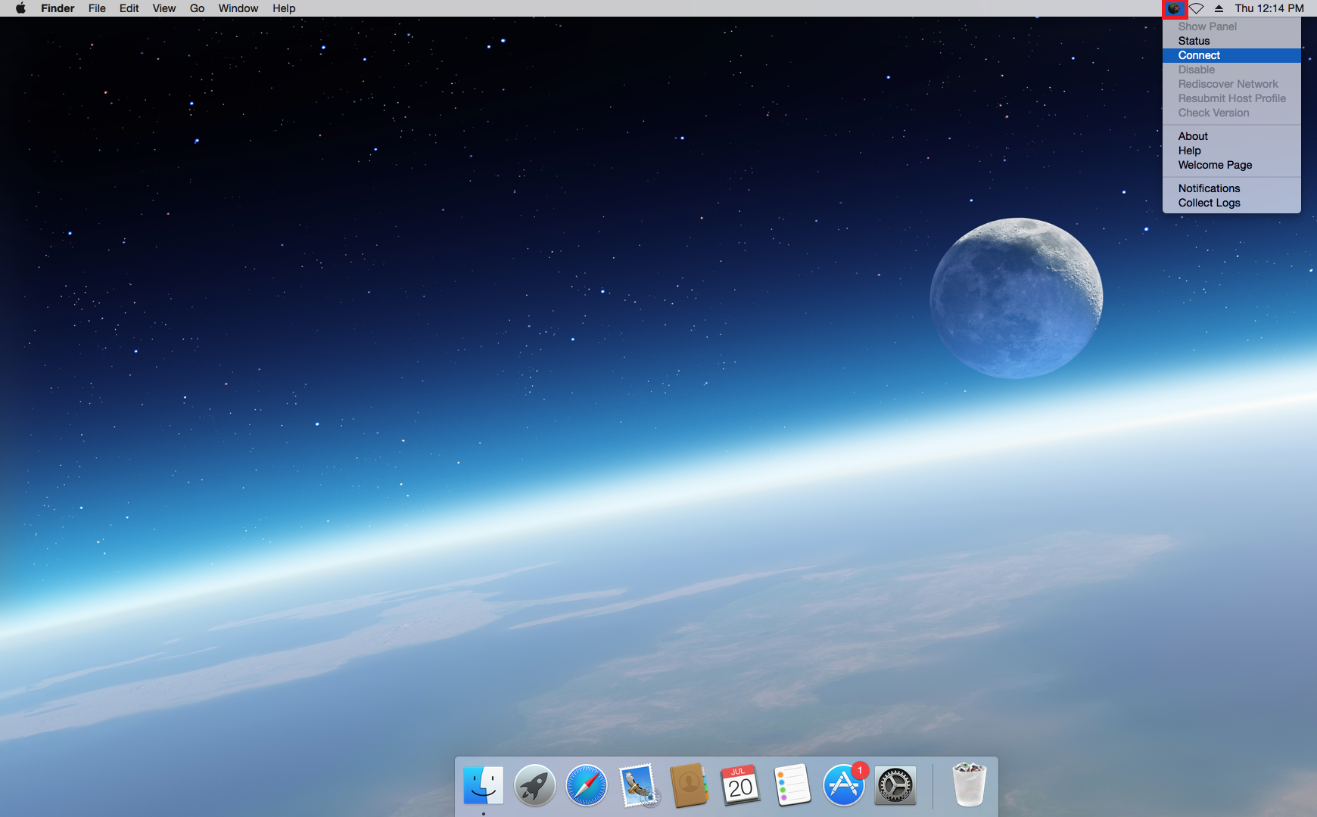

- Fill in the information accordingly and click on connect.
Portal: remote.lehman.edu
Username: Lehman username i.e. firstname.lastname
Password: Lehman password

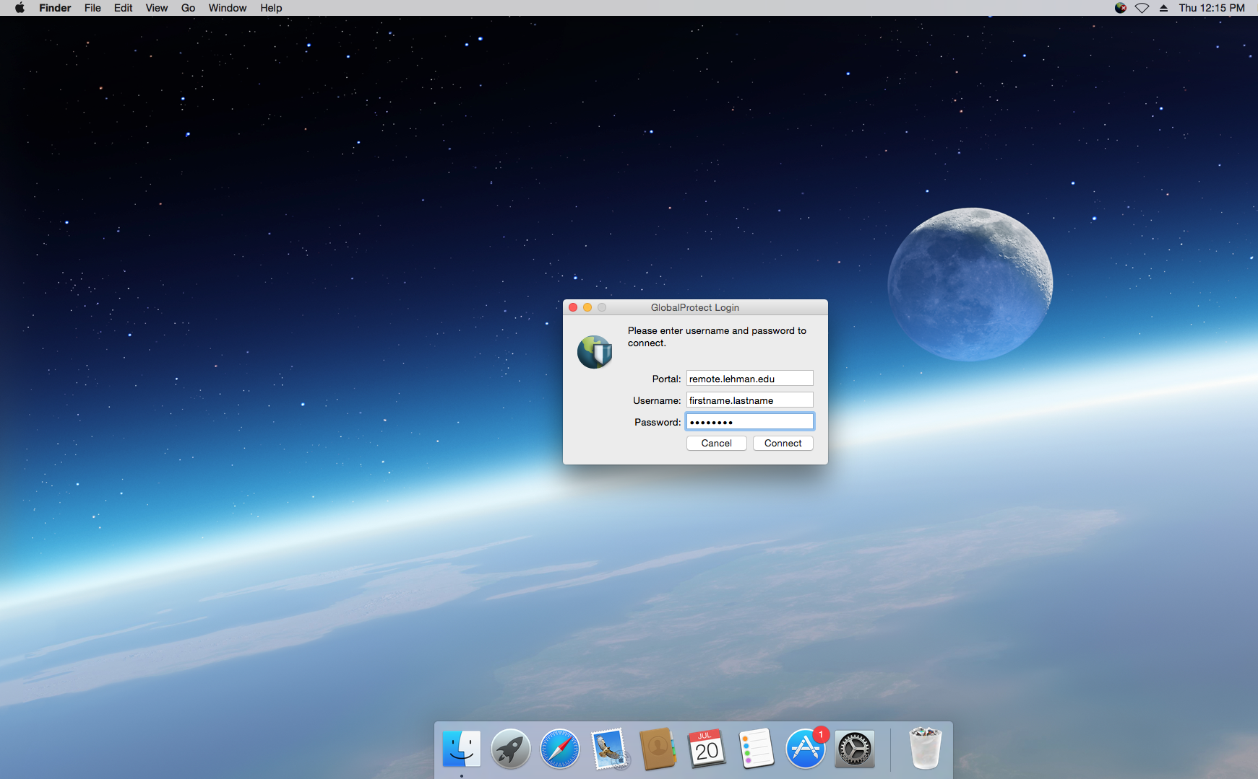

- If connected successfully, the Global Protect icon will have a small shield as displayed below.
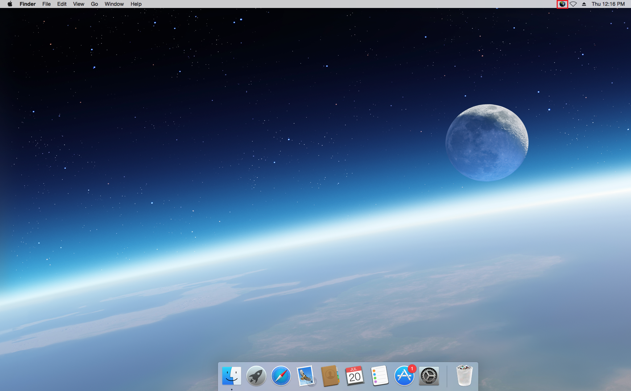

Once connected to the VPN you may access campus resources that are available only from the campus network. For example, faculty members that conduct research on campus servers may establish a remote session or SSH connection to their server.

- To disconnect, click on the Global Protect icon and click on “Disconnect”.
